Features

* locate user

Our APP will automatically locate the user when user open the APP and show the current location on the map. There will be a circle on the map which means user could only explore the post within this area.

* post information

without registration, user could post some feelings, thoughts using our APP and the their instant status will appear on the map as markers. User can post at most 140 words and we only support text in our first version. At one place, user can only have one post on the map and it will be kept for one hour if user does not update it. This way, we could keep the posts on the map updated and encourage user to update their status, thoughts frequently. User could update their post to reflect their current status or thought that they want to share with others. When user move one miles away with their previous post, we allow user to create new post on the map and the previous post will be kept for one hour.

* explore posts

when the APP is launched, a map will show and all the posts within one mile will show as marker on the map around current location. When user tap the marker, the first 10 words of the post will show in an information window. If user are interested in the details of the post, he could tap the information window, there will be a popup window show on the bottom of the screen with the full information of the post. At the bottom of the full information window, there will be three buttons named “Like”,”Don’t care” and “Report”.

* user’s action on post

User could report illegal and inappropriate information by Report button. Post with more like will become more outstanding on the map with darker color and will be more visible to other users. If user tap Don’t care, that means user do not want to see this post again, the post will remove from the user’s map and do not show again.

* management and control of content

As an anonymous APP, content control and management is important. We will show a warning page when user post first time to tell user not to post any illegal information or other people’s private information. If user keep violating the rules the user will be suspended for some time even removed permanently.

* merchant account

Merchant account is the core in our business model. Merchant could post promotion and sales information on our platform to attract customers around and we will charge for every promotion. Given we are location-based, the promotion would be more effective to reach the target customers. We regulate the merchant that they can post at most one promotion everyday and the merchant post will have different marker with general users, this way we can guarantee there will be not too much promotion information on our platform and will not damage the user experience. We will provide a setting for users to choose to show or not show promotion information on the map.

* Setting

We will provide a setting menu to let user filter the posts when there are too much posts around. User could use distance or time to filter and set the maximum posts showed on the map.

Screen Shot

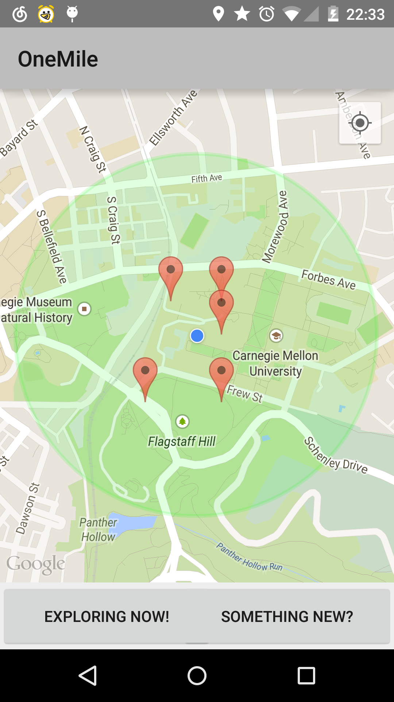

This is the main screen

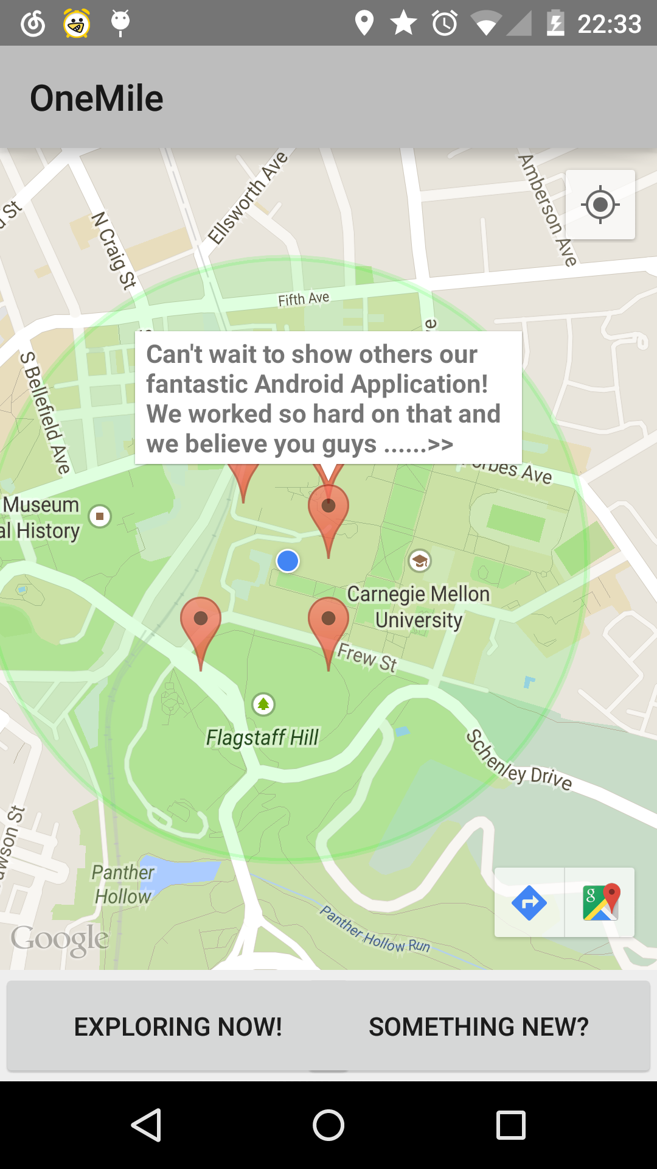

When the post is long, tabbing the marker will show the fragment of the post.

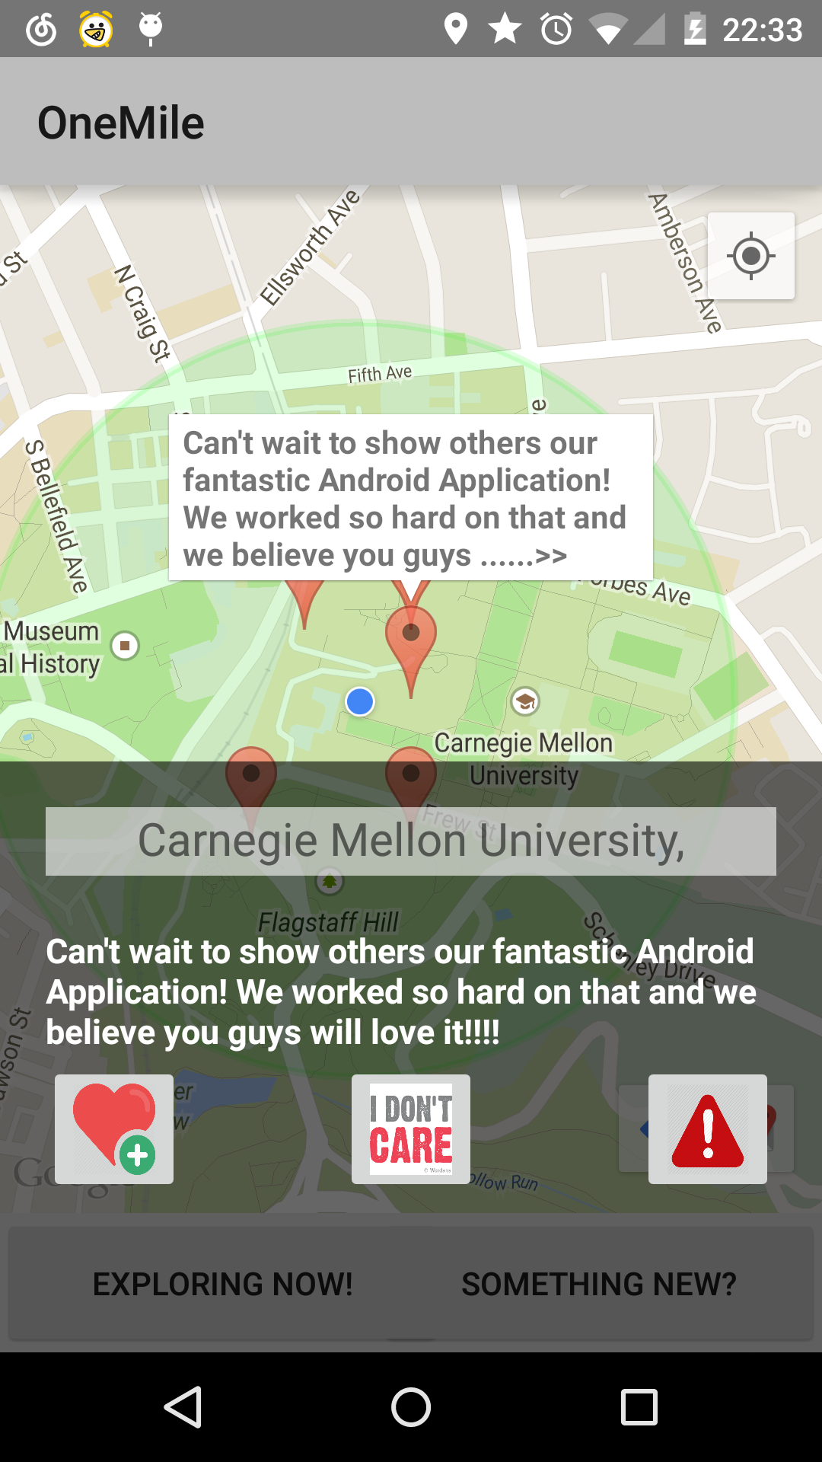

Tap the fragment, you have the full message. you can like it, you can press the “don’t care” button, and you can report it.

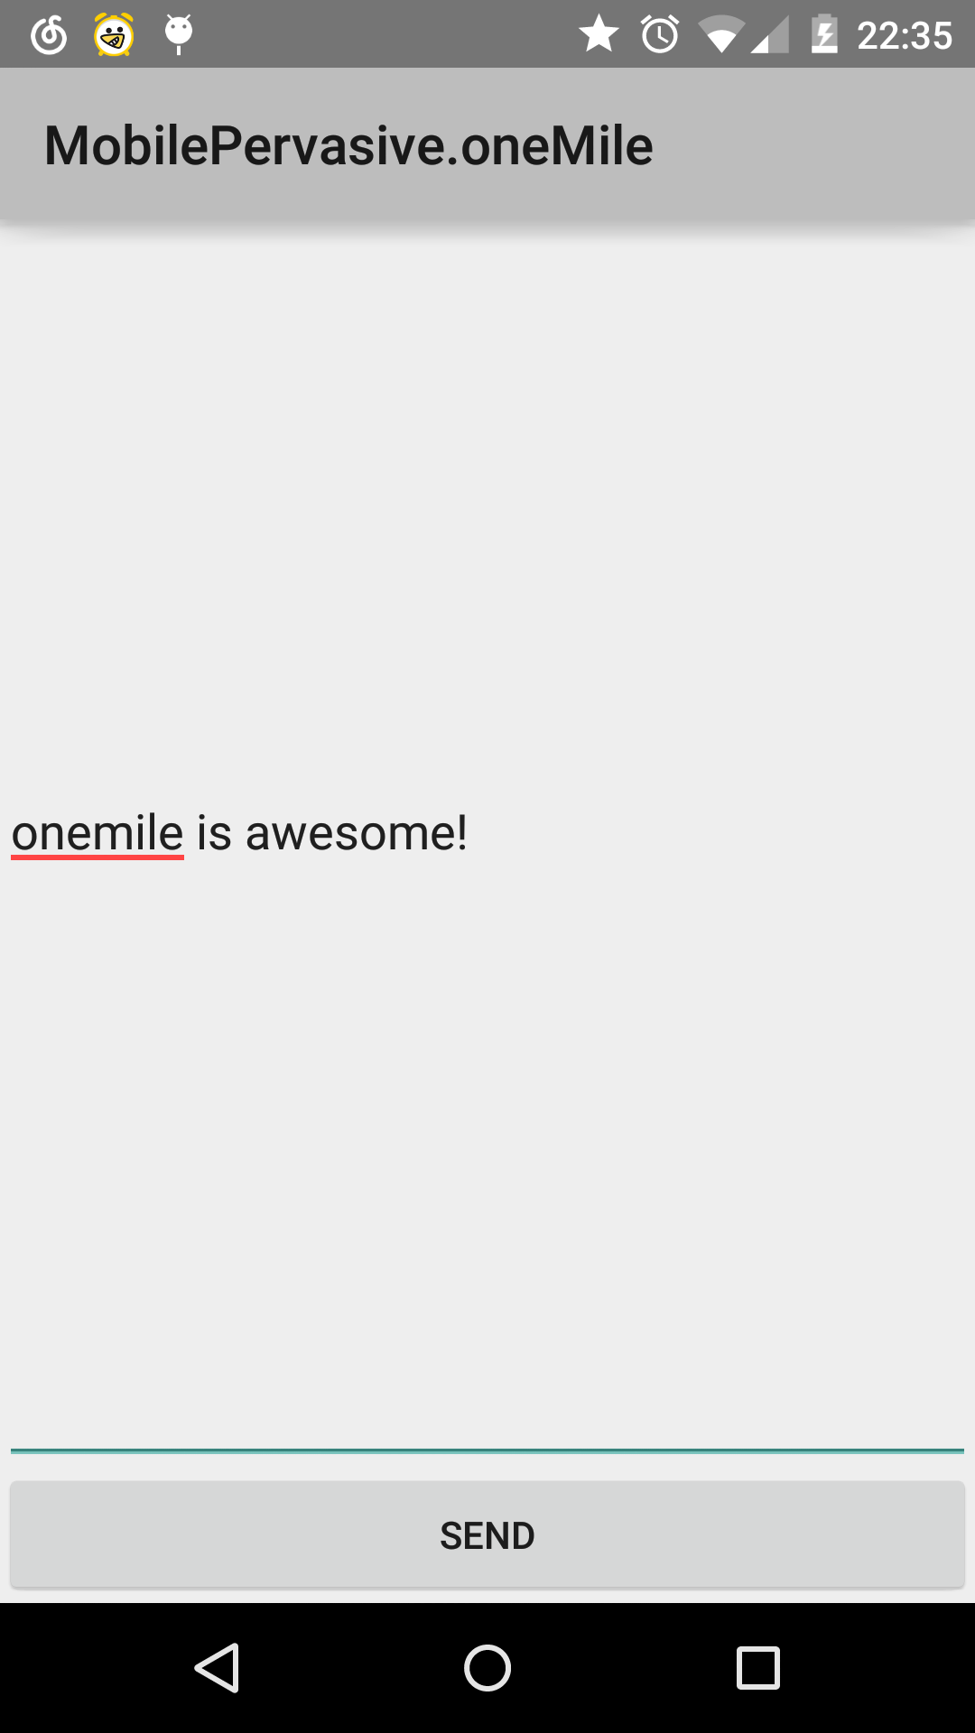

This is the screen of creating a new post.

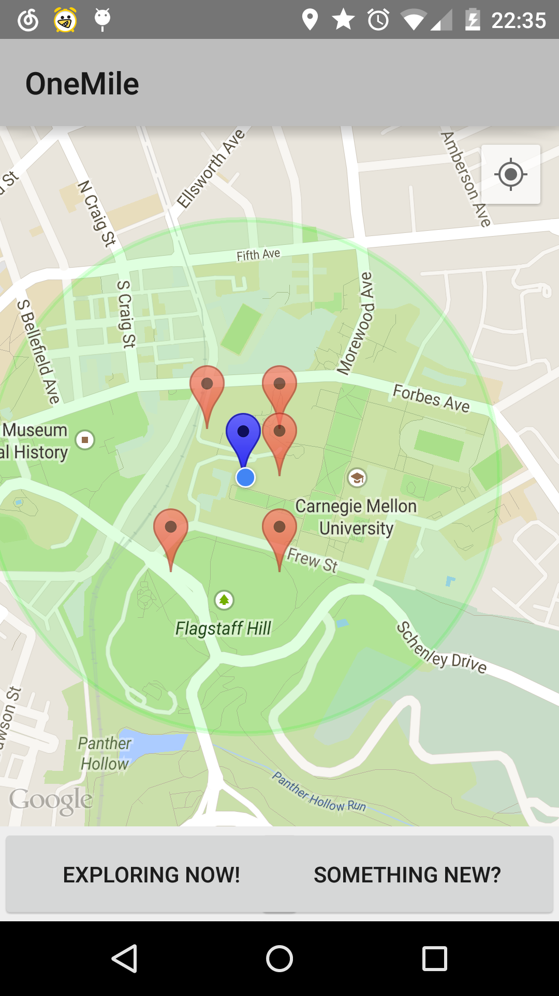

after you update your post, the blue marker represents your post.

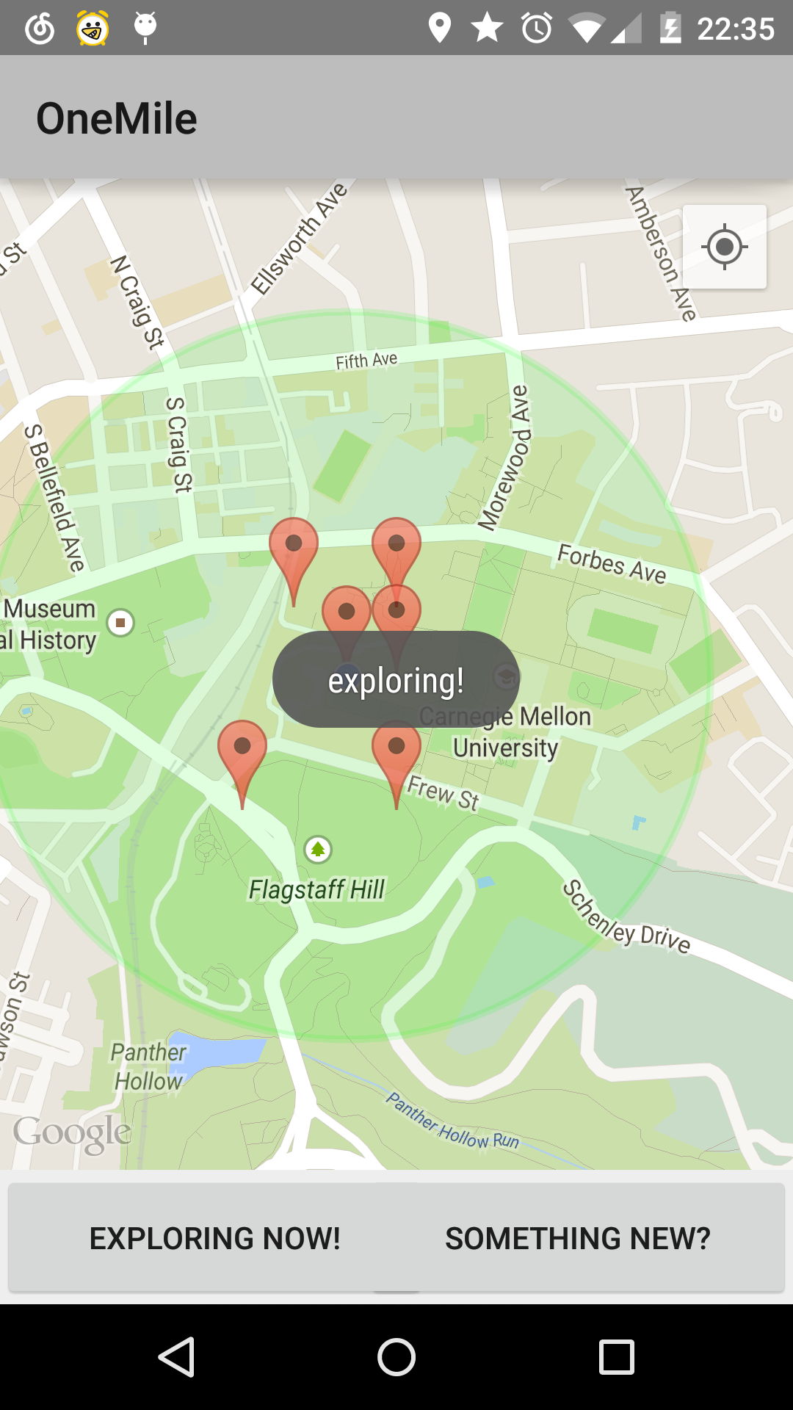

Press the “exploring now” button, you can refresh the map and get new posts.